**EX.No 1**

**Create a new Java project with “AddressDetails.java” file and implement a Java code to display your address.**

**Sample Output**

Door No: D089

Street: St. Louis Street

City: Springfield

ZIP Code: 62729

**ALGORITHM:**

STEP 1: Initialize the code

STEP 2: Enter the credentials to be displayed

STEP 3: Run the code in jdk and output is displayed

STEP 4: End of execution

**PROGRAM:**

package Unit1;

import java.util.Scanner;

public class DisplayEx1 {

    public static void main(String[] args) {

        Scanner input = new Scanner(System.in);

        System.out.println("Enter your Door no: ");

        String doorNo = input.nextLine();

        System.out.println("Enter your street: ");

        String street = input.nextLine();

        System.out.println("Enter your city: ");

        String city = input.nextLine();

        System.out.println("Door No: " + doorNo);

        System.out.println("Street: " + street);

        System.out.println("City: " + city);

        input.close();

    }

}

**OUTPUT:**

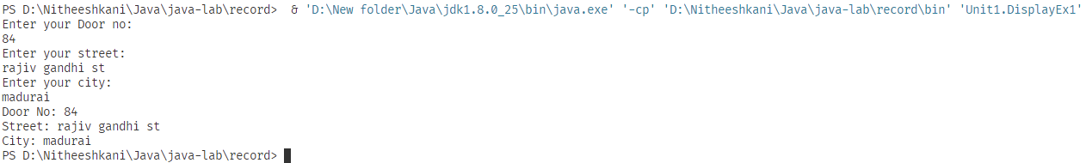

**Result:**

The program is Executed successfully

**EX.No 2**

**Implement a program to find the area of a circle by using the formula given below and display the calculated area.**

**Area = pi*radius*radius**

**The value of pi is 3.14.**

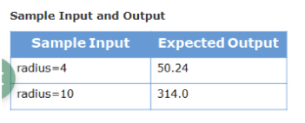

**ALGORITHM:**

STEP 1: Initialize the code

STEP 2: Enter the credentials to be displayed

STEP 3: Run the code in jdk and output is displayed

STEP 4: End of execution

**PROGRAM:**

package Unit1;

public class AreaCircleEx2 {

    public static void main(String[] args) {

        int radius = 2;

        double pi = 3.14;

        double area = pi * radius * radius;

        System.out.println(area);

    }

}

**OUTPUT:**



**Result:**

The program is Executed successfully

**EX.No 3**

**Implement a program to convert temperature from Fahrenheit to Celsius degree by using the formula given below and display the converted value.**

**C = ((F-32)/9)*5 where, C represents temperature in Celsius and F represents temperature in Fahrenheit.**

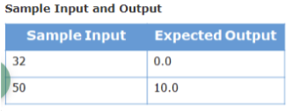

**ALGORITHM:**

STEP 1: Initialize the code

STEP 2: Enter the credentials to be displayed

STEP 3: Run the code in jdk and output is displayed

STEP 4: End of execution

**PROGRAM:**

package Unit1;

public class FtoCEx3 {

    public static void main(String[] args) {

        double F = 64;

        double C = ((F - 32) / 9) * 5;

        System.out.println(C);

    }

}

**OUTPUT:**



**Result:**

The program is Executed successfully

**EX.No 4**

**write a java program that does implicit conversion**

**ALGORITHM:**

STEP 1: Initialize the code

STEP 2: Run the code in jdk and output is displayed

STEP 3: End of execution

**PROGRAM:**

public class ImlicitConversionEx4 {

    public static void main(String[] args) {

        int i = 100;

        long l = i;

        float f = l;

        System.out.println("Int value " + i);

        System.out.println("Long value " + l);

        System.out.println("Float value " + f);

    }

}

**OUTPUT: Implicit**

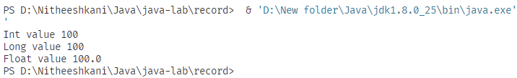

**Result:**

The program is Executed successfully

**EX.No 5**

**write a java program that does implicit conversion**

**ALGORITHM:**

STEP 1: Initialize the code

STEP 2: Run the code in jdk and output is displayed

STEP 3: End of execution

**PROGRAM:**

public class ExplicitConversionEx5 {

    public static void main(String args[]) {

        byte b;

        int i = 257;

        double d = 323.142;

        System.out.println("Conversion of int to byte.");

        b = (byte) i;

        System.out.println("i = " + i + " b = " + b);

        System.out.println("\nConversion of double to byte.");

        b = (byte) d;

        System.out.println("d = " + d + " b= " + b);

    }

}

**OUTPUT: Explicit**

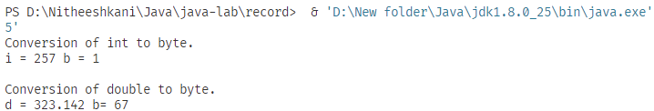

**Result:**

The program is Executed successfully

**EX.No 6**

**Implement a program to calculate the product of three positive integer values. However, if one of the integers is 7, consider only the values to the right of 7 for calculation. If 7 is the last integer, then display -1.**

**Note: Only one of the three values can be 7.**

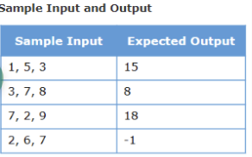

**ALGORITHM:**

STEP 1: Initialize the code

STEP 2: Run the code in jdk and output is displayed

STEP 3: End of execution

**PROGRAM:**

package Unit1;

import java.util.Scanner;

public class ConditionMathEx6 {

    public static void main(String[] args) {

        int pro = 1, x;

        Scanner scan = new Scanner(System.in);

        for (int i = 0; i < 3; i++) {

            System.out.print("Enter the " + (i + 1) + "st number:");

            x = scan.nextInt();

            pro *= x;

            if (x == 7 && i == 2) {

                pro = -1;

            } else if (x == 7) {

                pro = 1;

            }

        }

        System.out.println(pro);

        scan.close();

    }

}

**OUTPUT:**

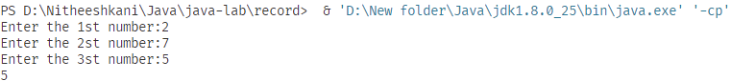

**Result:**

The program is Executed successfully

**EX.No 7**

**Food Corner home delivers vegetarian and non-vegetarian meals to its customers based on the order. A Vegetarian combo costs $12 per plate and a non-vegetarian combo costs $15 per plate. Apart from the cost per plate of food, customers are also charged for home delivery based on the distance in kms from the restaurant to the delivery point. The delivery charges are as mentioned below:**

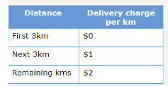

**ALGORITHM:**

STEP 1: Initialize the code

STEP 2: Run the code in jdk and output is displayed

STEP 3: End of execution

**PROGRAM:**

package Unit1;

import java.util.Scanner;

public class FoodCornerEx7 {

    public static void main(String[] args) {

        Scanner scan = new Scanner(System.in);

        int vegPrice = 12;

        int nonVegPrice = 15;

        System.out.println("Enter meal package V or N");

        String order = scan.nextLine();

        System.out.println("Enter meal package quantity");

        int quantity = scan.nextInt();

        System.out.println("Enter distance");

        double distance = scan.nextDouble();

        double total = 0;

        if (order.equals("V"))

            total = vegPrice * quantity;

        else if (order.equals("N"))

            total = nonVegPrice * quantity;

        else

            total = -1;

        if (distance < 6)

            total += (distance - 3) * 1;

        else

            total += 3 + (distance - 6) * 2;

        System.out.println("Foodtype   quantity   distance   total");

        System.out.println("\t" + order + "\t" + quantity + "\t" + distance + "\t" + total);

        scan.close();

    }

}

**OUTPUT:**

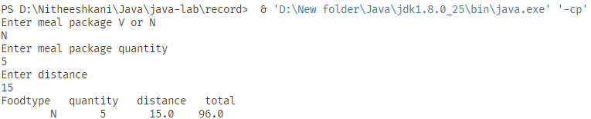

**Result:**

The program is Executed successfully

**EX.No 8**

**Implement a program to display the geometric sequence as given below for a given value n, where n is the number of elements in the sequence.**

**1, 2, 4, 8, 16, 32, 64, ......, 1024**

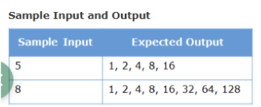

**ALGORITHM:**

STEP 1: Initialize the code

STEP 2: Run the code in jdk and output is displayed

STEP 3: End of execution

**PROGRAM:**

package Unit1;

import java.util.Scanner;

public class GeoSeqEx8 {

    public static void main(String[] args) {

        Scanner scan = new Scanner(System.in);

        System.out.println("Enter the value of n: ");

        int n = scan.nextInt();

        scan.close();

        int value = 1;

        for (int i = 1; i <= n; i++) {

            System.out.print(value + "  ");

            value *= 2;

        }

    }

}

**OUTPUT:**



**Result:**

The program is Executed successfully

**EX.No 9**

**Implement a program to find the number of rabbits and chickens in a farm. Given the number of heads and legs of the chickens and rabbits in a farm, identify and display the number of chickens and rabbits in the farm. If the given input cannot make a valid number of rabbits and chickens, then display an appropriate message.**

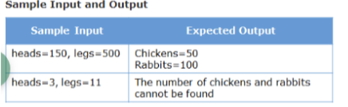

**ALGORITHM:**

STEP 1: Initialize the code

STEP 2: Run the code in jdk and output is displayed

STEP 3: End of execution

**PROGRAM:**

package Unit1;

public class ChicRabbitEx9 {

    public static void main(String[] args) {

        int head = 150, legs = 500;

        double x, y;

        x = (legs - 2 * head) / 2;

        y = head - x;

        System.out.println("Chickens = " + x + " Rabbits = " + y);

    }

}

**OUTPUT:**



**Result:**

The program is Executed successfully